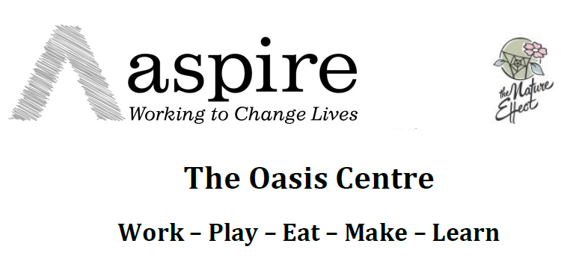
Contact Scott Urban  Telephone 07737 281615  Email scott.urban@gmail.com | FOR IMMEDIATE RELEASE  3 May 2017

MOMENTUM BUILDS FOR CHILDREN’S CENTRE

Petition for Florence Park children’s centre surpasses 1000 signatures
Oxford, 27 April 2017– More than 1000 people have signed a petition to keep the Florence Park Children’s Centre a locally managed enterprise. The petition supports the bid from Aspire Oxford and The Nature Effect to incubate a locally managed and run “Oasis Centre” which combines children’s services, café and shared workspace.
“We are incredibly excited to attract the support of so many local residents. This is a viable proposal and we are certain the community will be there to support us if we get the chance to move forward. This seems to have sparked something in people’s imagination and aspirations for what ‘community’ can mean.” Annie Davy, The Nature Effect, Co-Sponsor of the bid
Oxford County Council is in the third and final round of decision-making over the re-purposing of some of Oxfordshire’s children’s centres. The bids to run the children’s centre in Florence Park, East Oxford, have been put through two rounds and now await a final decision. One of the bids is by Aspire Oxford and the Nature Effect, which propose to incubate a locally run and managed centre, “The Florence Park Centre for Children & Families”.
The centre would generate income from childcare, a café and catering operation, the letting of hot desks and meeting space and from running training courses. It is intended to be entirely self-sustaining and financially viable within three years and have no dependency on grants or other public sector income other than for statutory childcare places funded by the government. Critically, any surplus income will be ploughed back into the centre, services and community.
# # #
Notes to editors
The petition can be found at https://goo.gl/u1kNlF
Aspire is supporting local residents and community organisations in Florence Park, including The Nature Effect, with a bid to secure an initial £10k interim grant award from Oxfordshire County Council’s Transition Fund.
The fund would be used by Aspire to support Florence Park community organisations and residents to help develop a proposal to implement a locally managed, sustainable, community enterprise for children & families at the vacant Florence Park Centre, and to provide a programme of regular family support activities in and around Florence Park over the summer period while the enterprise is developed further.
This proposal seeks to develop the proposal put forward to the previous 2 Transition Fund Grant panels by the Nature Effect CIC – a proposal which has considerable, strong local support.
If you would like more information about this topic, please contact Scott Urban at 07737 281615 or scott.urban@gmail.com.

